**DAILY ONLINE ACTIVITIES SUMMARY**

|  |  |  |  |  |  |  |  |  |
| --- | --- | --- | --- | --- | --- | --- | --- | --- |
| **Date:** | **27/05/2020** | | | | | **Name:** | **Archana J C** | |
| **Sem & Sec** | **4th**  **‘A’** | | | | | **USN:** | **4AL18CS011** | |
| **Online Test Summary** | | | | | | | | |
| **Subject** | | **Object oriented concepts** | | | | | | |
| **Max. Marks** | | **30** | | **Score** | | | **29** | |
| **Certification Course Summary** | | | | | | | | |
| **Course** | **Data visualization using python** | | | | | | | |
| **Certificate Provider** | | | **Great learning academy** | | **Duration** | | | **4 hours** |
| **Coding Challenges** | | | | | | | | |
| Write a C Program to sort an array of integers in ascending order and display the sorted array and Number of passes performed for sorting | | | | | | | | |
| **Status: Completed** | | | | | | | | |
| **Uploaded the report in Github** | | | | | **Yes** | | | |
| **If yes Repository name** | | | | | **archana_j_c** | | | |
| **Uploaded the report in slack** | | | | | **Yes** | | | |

Online Test Details: (Attach the snapshot and briefly write the report for the same)

The online test is from Object oriented concepts module 5. Which is about applets in java and etc.. the test was easy and test was conducted for 30 marks, duration is 30 minutes. I was scored 29/30.

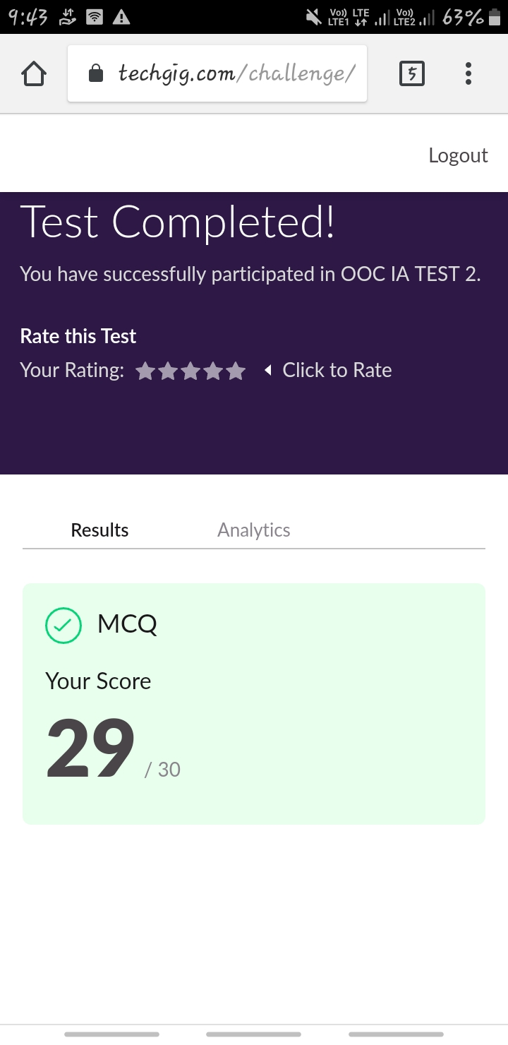

Certification Course Details: (Attach the snapshot and briefly write the report for the same)

COURSE NAME : Data visualization using python

CERTIFICATION PROVIDERS : Great learning academy

Today I leant about the introduction to visualization, matplotlib, seaborn, and plotly etc..



Coding Challenges Details: (Attach the snapshot and briefly write the report for the same)

Today I’m done with some c programs. The solution are already uploaded in github repository

PROBLEM : Write a C Program to sort an array of integers in ascending order and display the sorted array and Number of passes performed for sorting

